

**Report**

Drawing/Sketching Competition

**“Inculcating Swachh Bharat in Our Daily Practices”**

Organized by

Department of Chemistry

&

Department of Environmental Science

The Department of Chemistry in collaboration with the Department of Environmental Science organized a Drawing/Sketching writing competition on the theme “**Inculcating Swachh Bharat in Our Daily Practices”** on **26th August, 2023** in Academic Block D (D113) at 11:00 am onwards. To accelerate the efforts to achieve universal sanitation coverage and to put the focus on sanitation, the Prime Minister of India had launched the Swachh Bharat Mission on 2nd October 2014. The sanitation and hygiene practices must be adopted and inculcated in our daily routine to avert spread of contagious diseases and for good health. Access to safe water, sanitation and hygiene is the most basic human need for health and well-being. Billions of people will lack access to these basic services in 2030 unless progress quadruples. **The Sustainable Development Goal 6** on “**Clean Water and Sanitation”** also endorses and emphasizes the importance of sanitary practices. A total of 19 beautifully rawn sketches were submitted which were judged by Dr. Rahila Rahman Khan, Assistant Professor, Department of Environmental Science and Dr. Idrees Ahamd Khan, Assistant Professor, Department of Physics. The activity was coordinated by Dr. Tahmeena Khan, Assistant Professor, Department of Chemistry and Dr. Amina Jafri, Assistant Professor, Department of Environmental Science. The winners of the competition were:

**1. Azmeen Khan (B.Sc. PCM, Ist year)**

**2. Ankit Kumar (M.Sc. Chemistry, Ist year)**

**3. Ayush Tripathi (B.Sc. PCM, Ist Year)**

**Glimpses of the event**

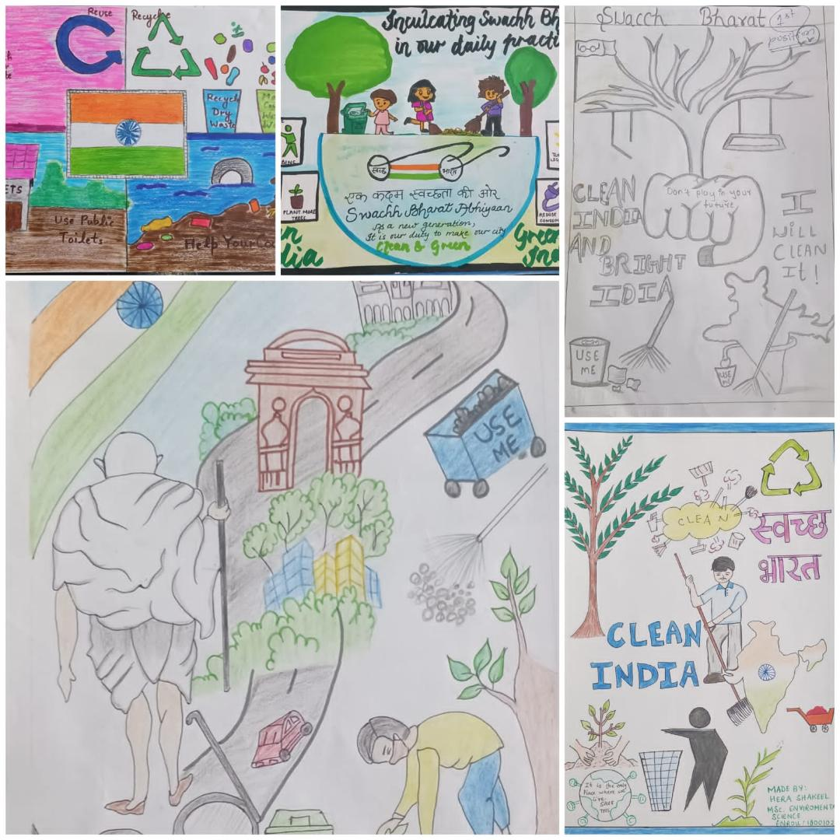 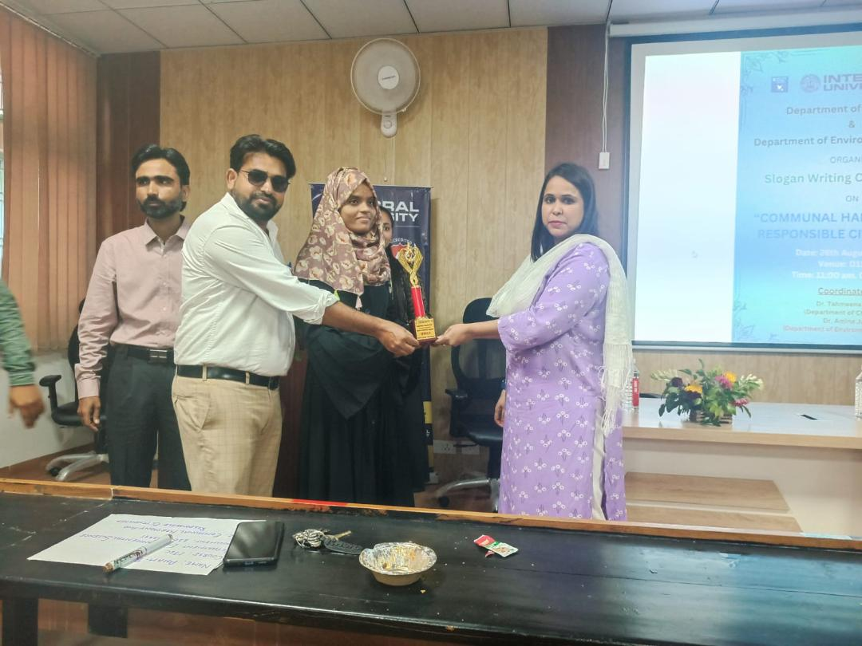

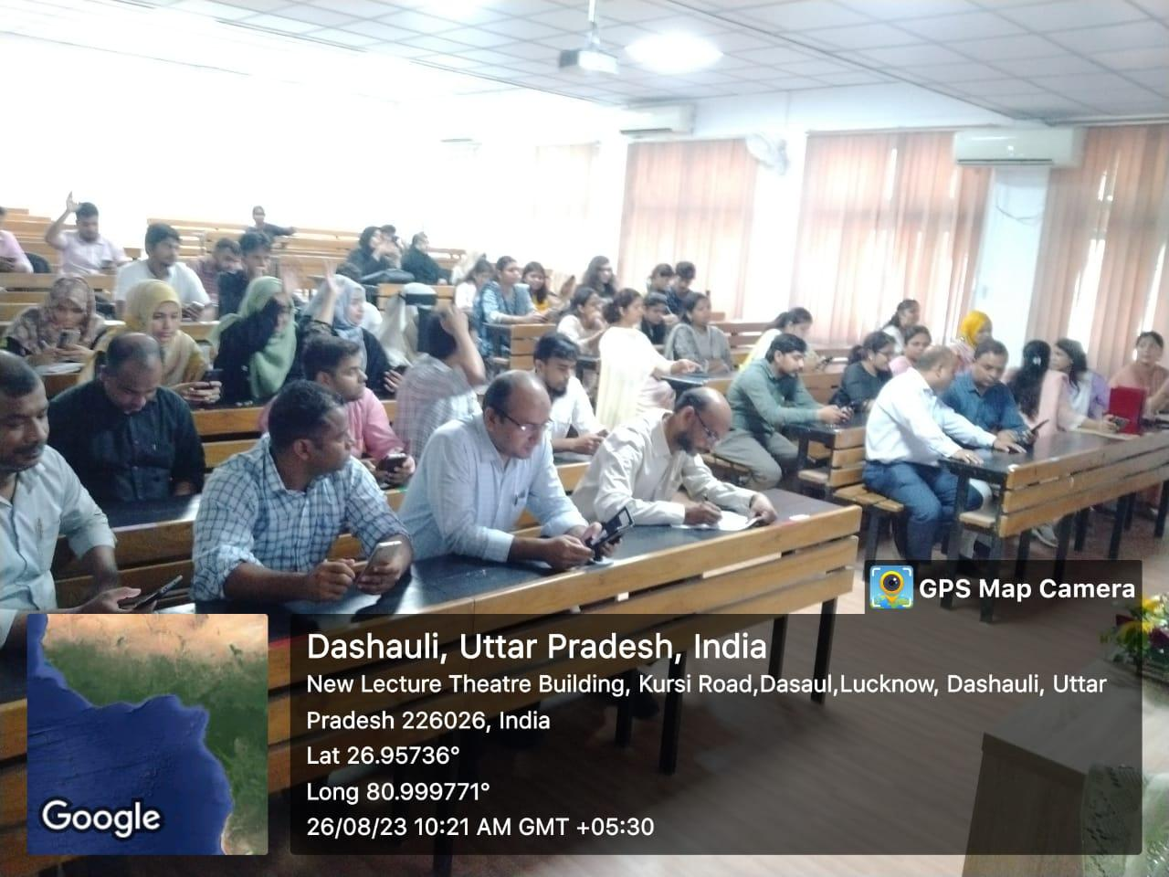 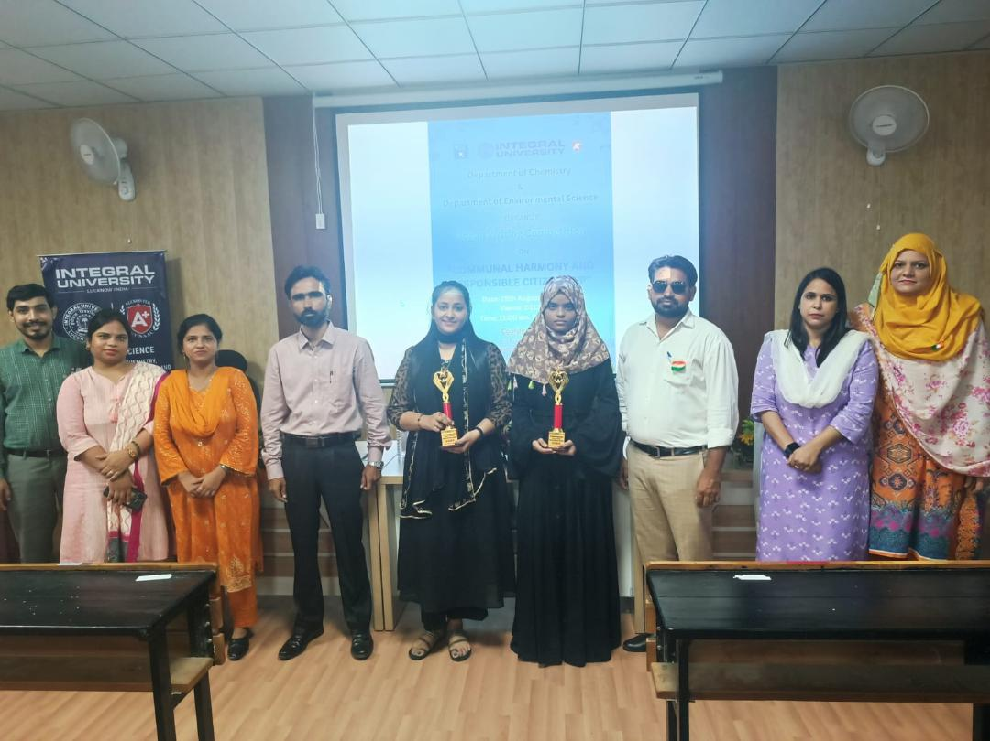

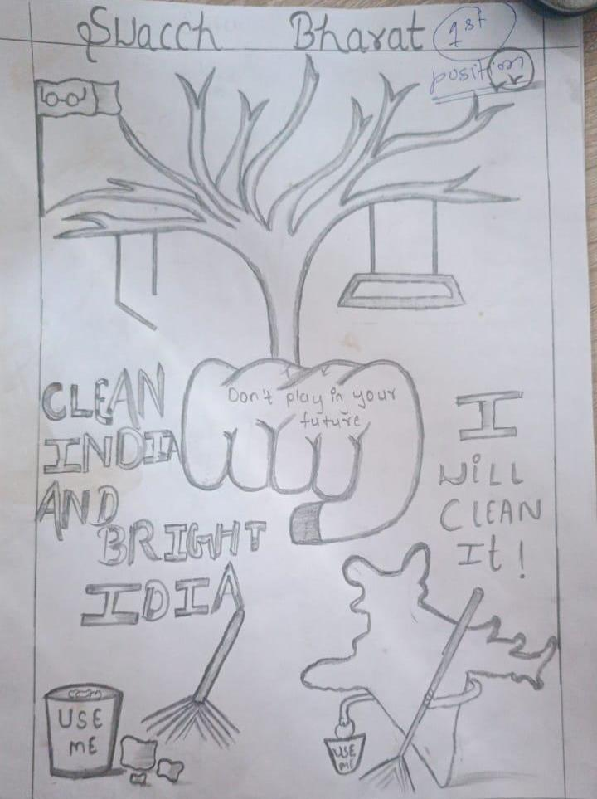

Submitted by

Dr. Tahmeena Khan

Dr. Amina Jafri